**Sheikh Tech**



Session: 2023 – 2027

**Submitted by:**

M.Tayyab Amir 2023-CS-101

**Supervised by:**

Prof. Dr. Muhammad Awais Hassan

**Course:**

CSC-103 Object Oriented Programming

Department of Computer Science

**University of Engineering and Technology Lahore Pakistan**

**Introduction:**

A Tech is a place which gives information about the latest technology devices/things to the customer and customers can buy those things according to their will or need. He can get different information related to these devices/things i.e. Price of the device, its company and which device he can get in his budget. This business application will ask the customer about his maximum range and the device (He wants to buy) and the program will show him the device according to his range and its price with the discount (if applicable).The shop also includes second hand devices for the customers as many people like to buy second hand devices. Admin of the shop can change the prices of devices, add devices and delete devices.

**OOP-CONCEPTS:**

The major concepts of OOP that have been used in this project include Association which further comprises Aggregation and Composition. The other major concept that has been used is Inheritance.

* **Association:**

Aggregation and Composition have been used a number of times in the project, especially aggregation.

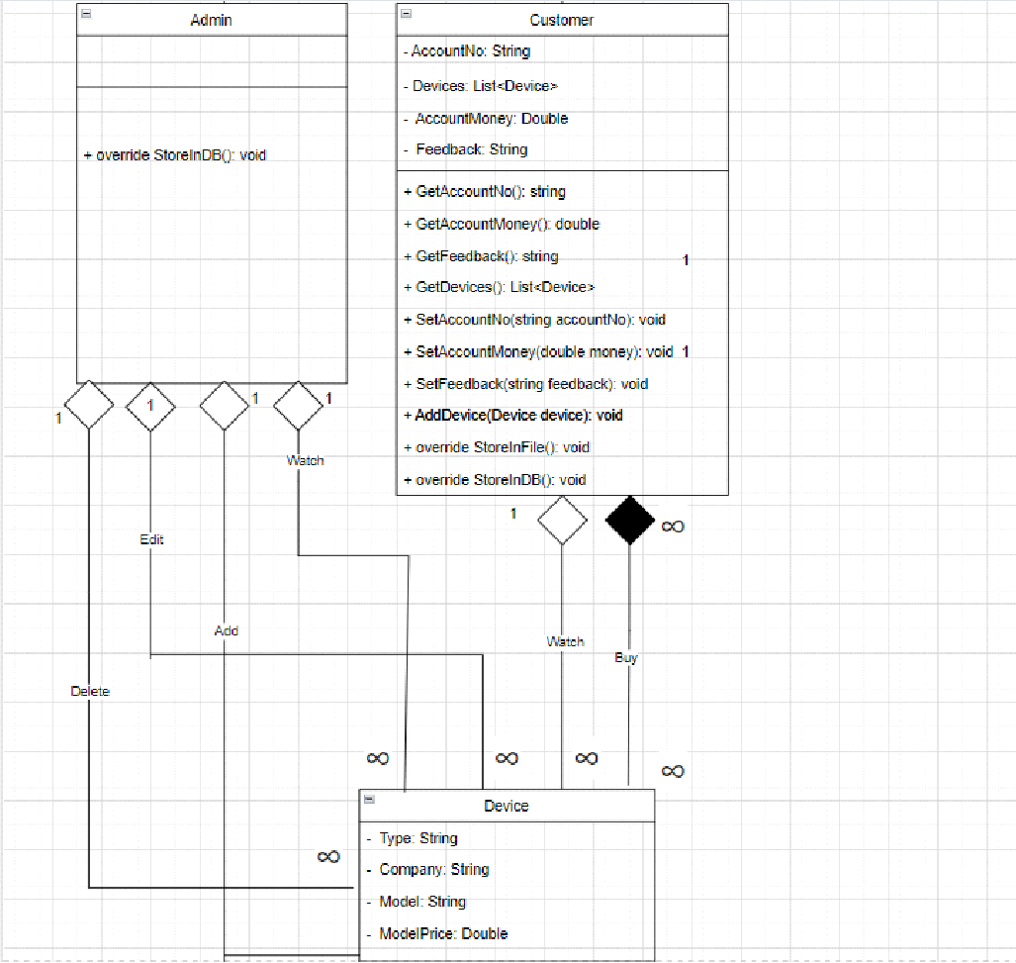

Figure 1

* **Encapsulation:**

Encapsulation is a fundamental principle of OOP that involves bundling data and related methods within a class, hiding the internal implementation details from other parts of the system. In the tech shop, encapsulation can be employed to encapsulate the properties and methods of classes such as Admin, Customer and Device protecting their internal state and providing controlled access to their data.

* **Inheritance:**

Inheritance is used to reduce the duplication of data. By using inheritance, attributes can only be declared in a single parent class and then all of these can be used in child classes with the help of inheritance. This approach reduces the replication of data. The attributes in the parent class can be made either protected or private.

'

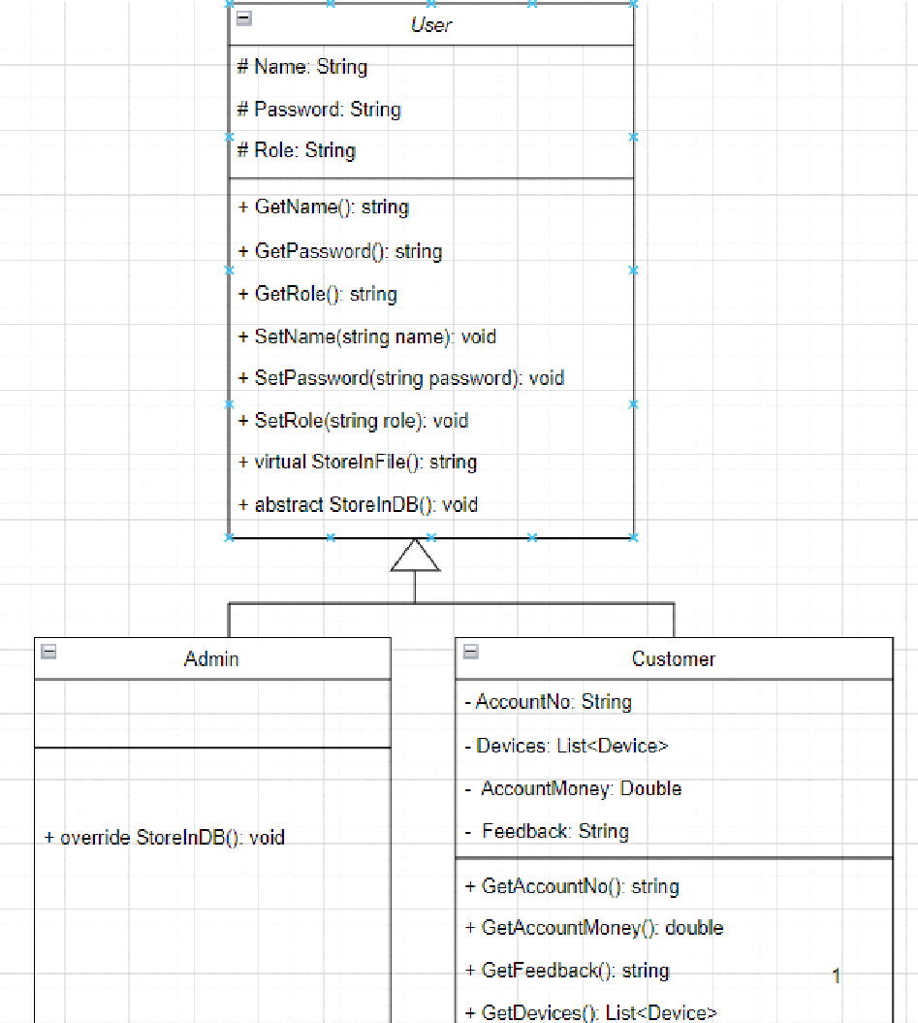

Figure 2

In the above diagram User is the parent class and Admin and Customer are the child classes. The attributes of parent class can be accessed by child classes. This is a conventional way of reducing replication.

* **Polymorphism:**

Polymorphism enables objects of different classes to be treated interchangeably, allowing for flexibility and extensibility in the system. In the blood donation management system, polymorphism can be applied when handling different types of donors and recipients. Methods or functions that operate on donors or recipients can be designed to accept objects of the general class type named Person, enabling the system to handle various specific instances transparently. It is also helpful when storing it into a list.

* **DESIGN PATTERN IMPLEMENTATION:**

The whole project is totally based upon the three types of layers i.e. BL, DL and UI. The BL folder contains all the BL classes ,the DL folder contains all the DL classes and the UI folder contains all the UI classes All the attributes, constructors and logics are placed in the BL layers. The operations that are to be performed on the data are placed in the DL layers. The UI layers contain all those things that should be displayed on the screen. Moreover all the lists are placed in the respective DL layers. All these are connected with each other through different relations. The DL layers first get access to the BL layers to get the attributes. The UI layers need DL for performing different operations on data. In this way all layers are connected with each other in some way.

* **CLASSES DETAILS:**

The major classes in the project are User and Device and their purpose and responsibilities are given.

* **User:**

This class contains all the functions that are to be performed on the users of this application like on customers and admins .This is also a parent class which further consists of Customer and Admin classes. All the responsibilities related to any of the users are performed through this class or its child classes.

* **Admin:**

Admin is the child class of user, and it is responsible for admin’s operation.

* **Customer:**

Admin is the child class of user, and it is responsible for customer’s operation.

* **Device:**

This class contains all attributes and their getter setter related to the device. All the functionalities related to any device are done using these classes. This class also interacts with other classes for several purposes like Admin class is capable of adding a new device in the shop,however their existence does not depend on one another.

* **CRC Model:**

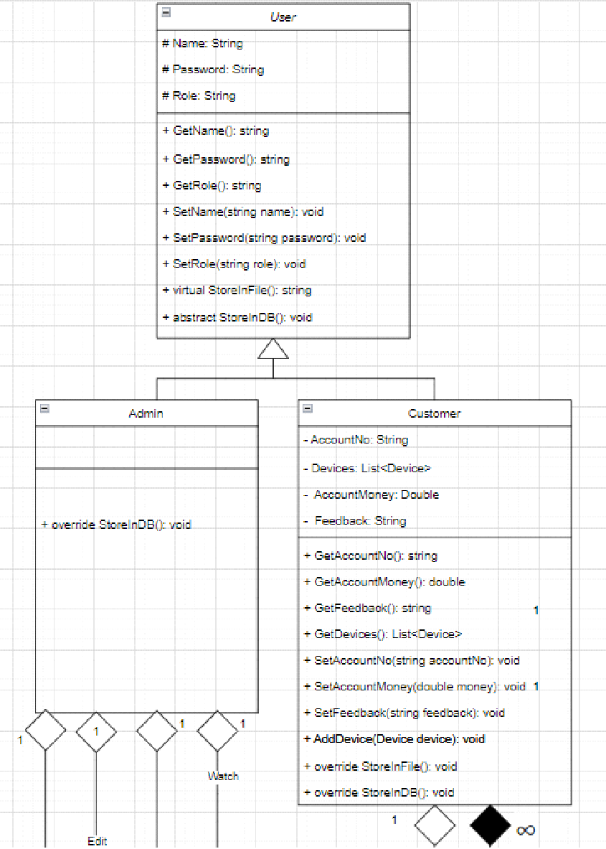

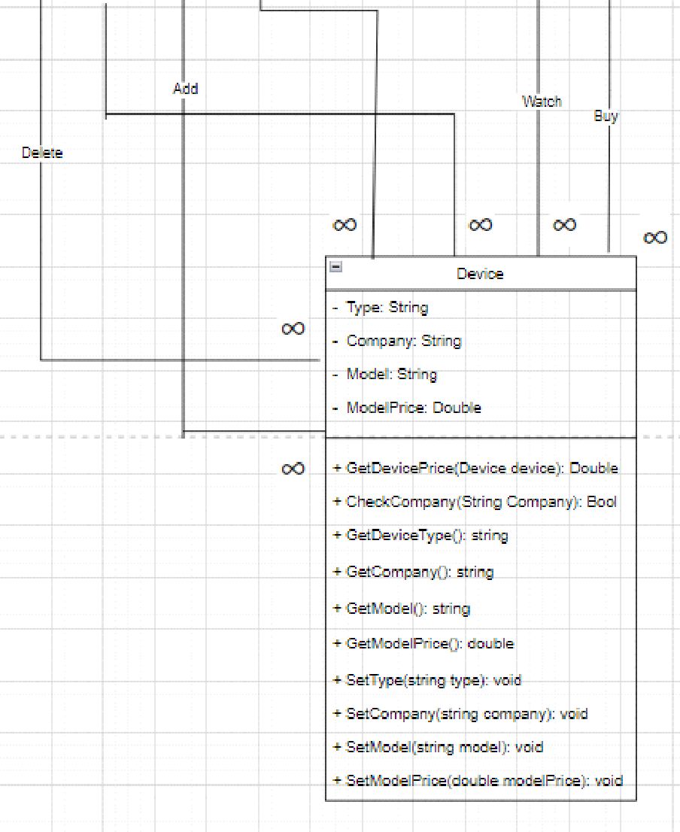

* **Wireframes:**

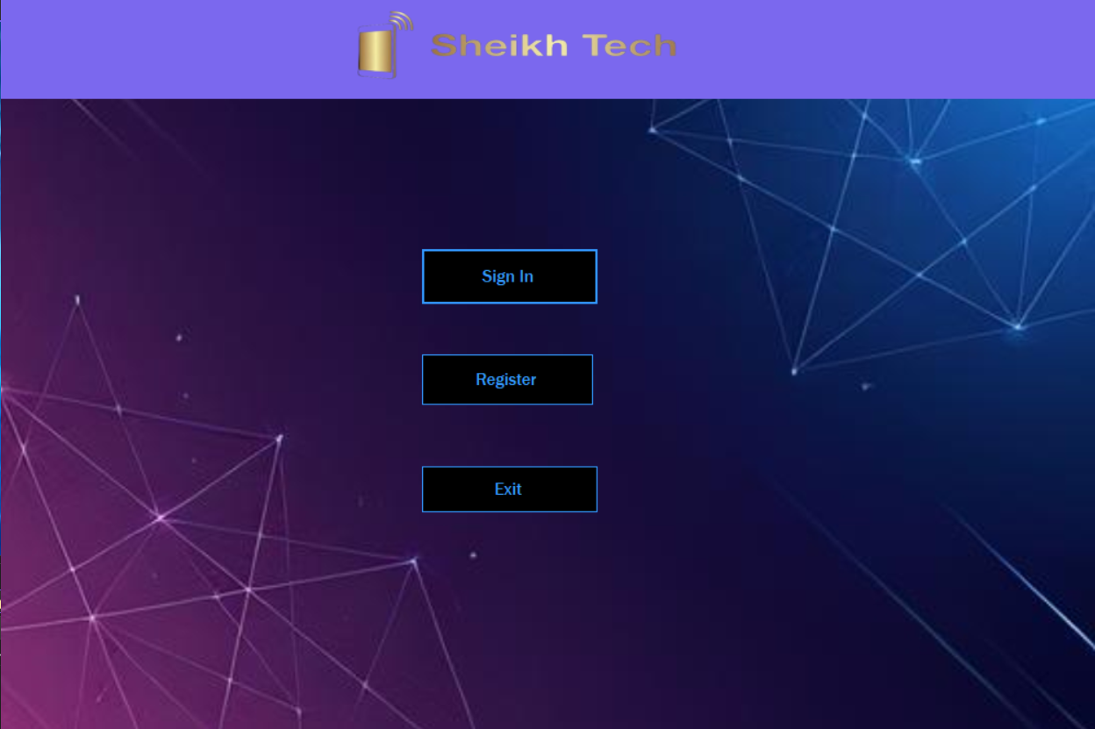

**Figure 1: Home**

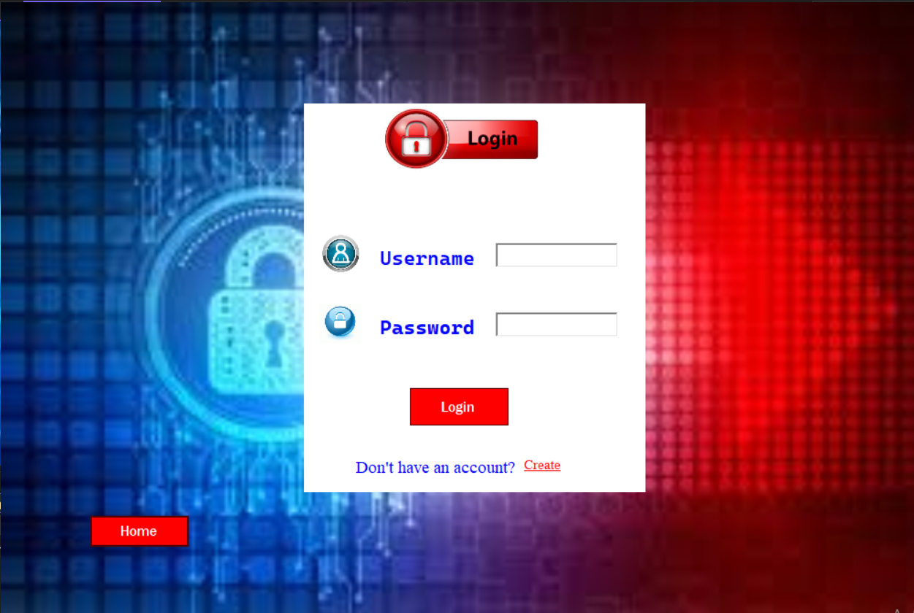

**Figure 2: Login**

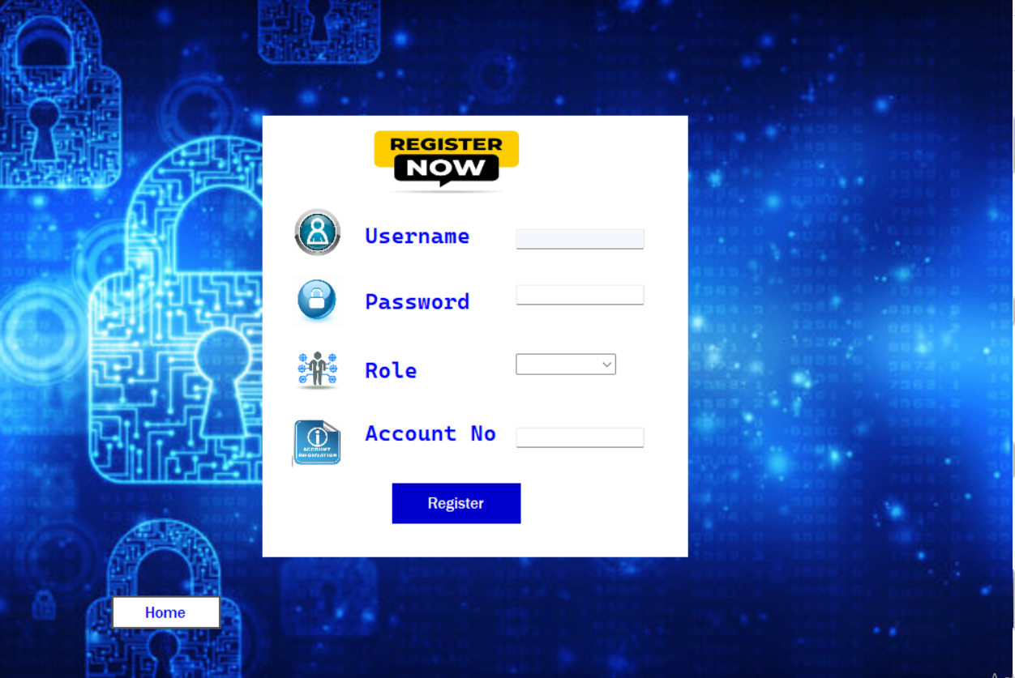

**Figure 3: Sign Up**

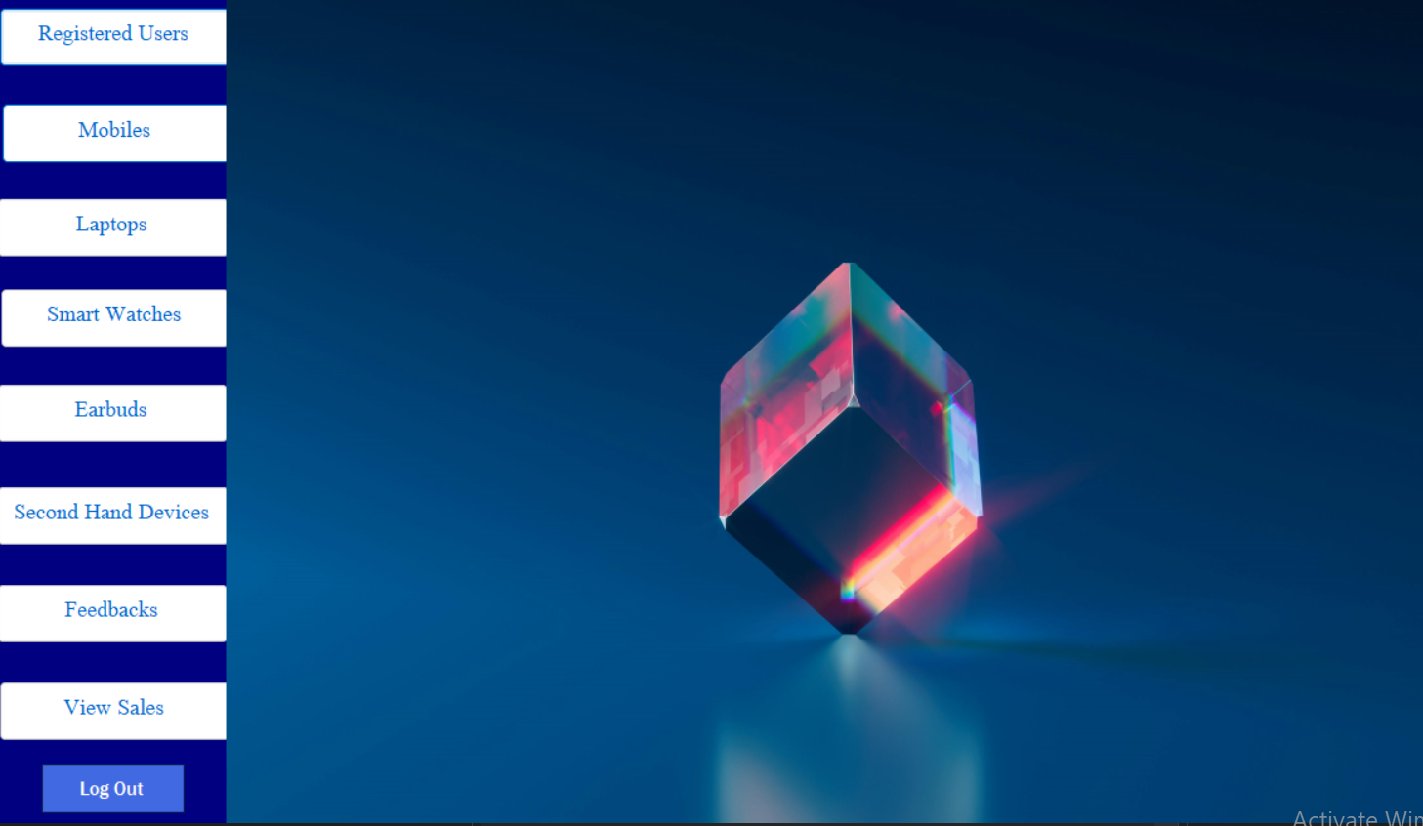

**Figure 4: Admin Menu**

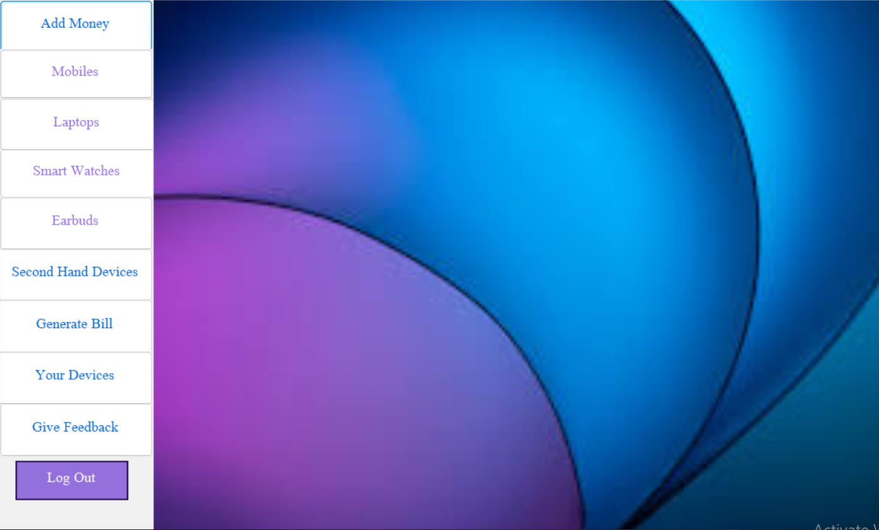

**Figure 5: Customer Menu**

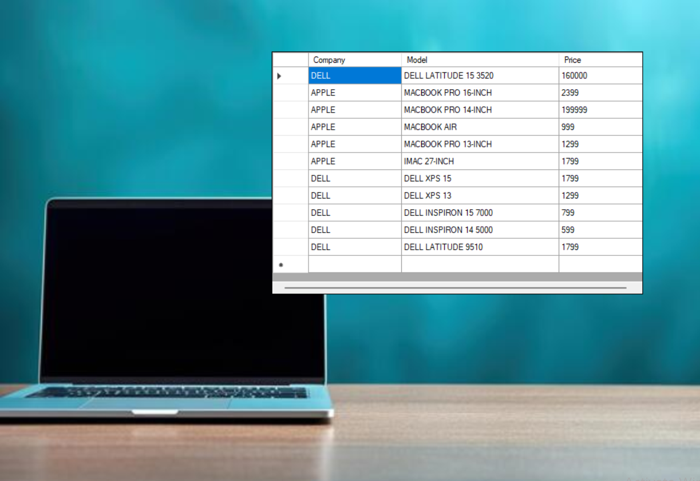

**Figure 6: View Devices**

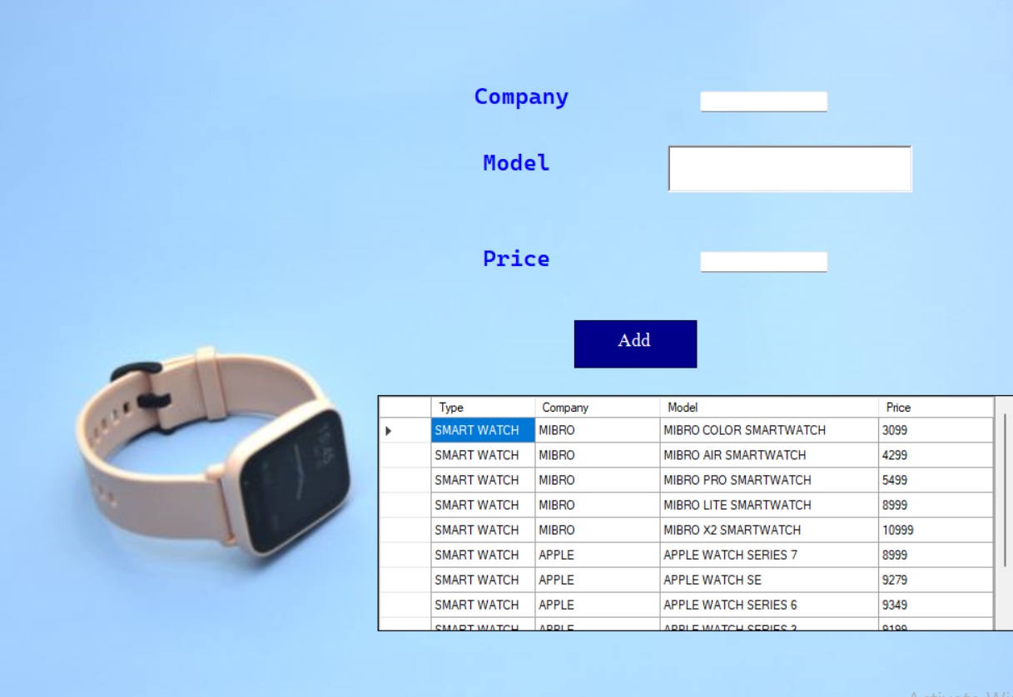

**Figure 7: Add Device**

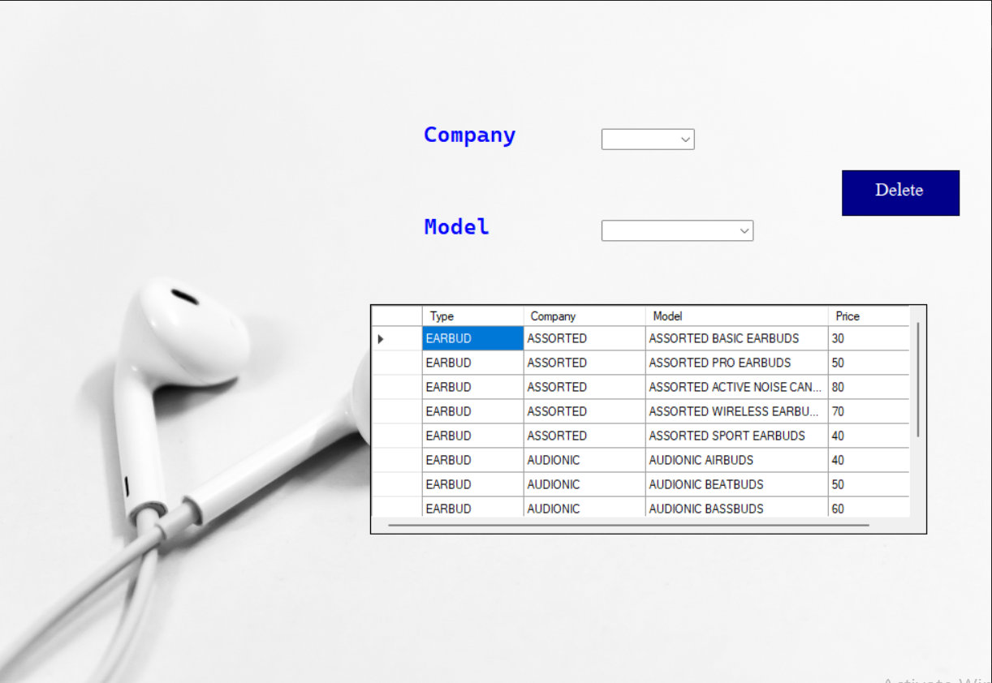

**Figure 8: Delete Device**

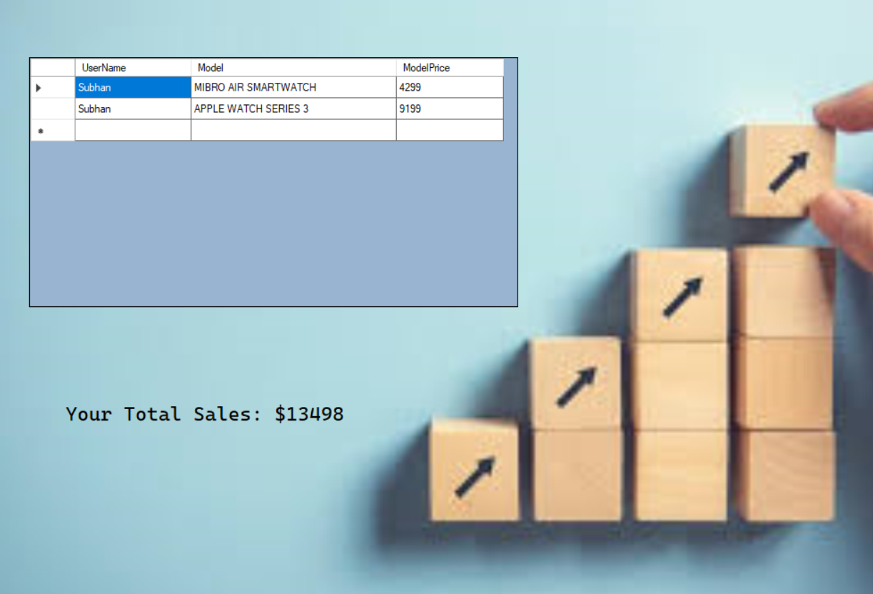

**Figure 9: Sales**

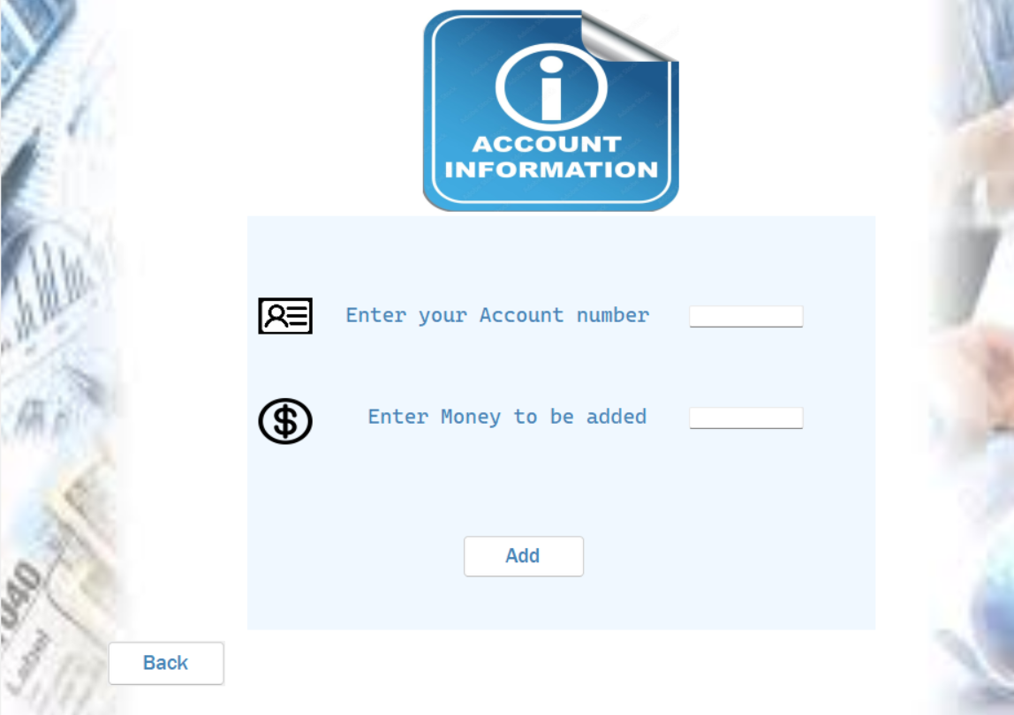

**Figure 10: Account Information**

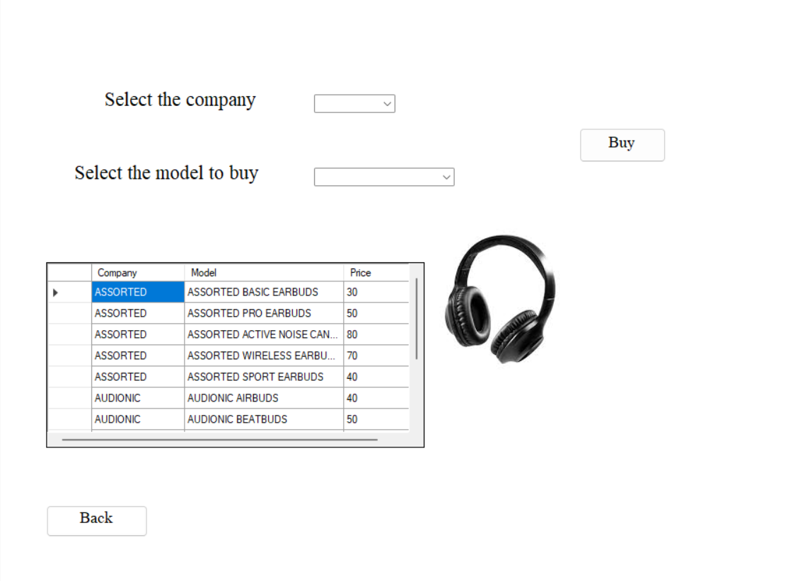

**Figure 11: Buy Device**



**Figure 12: Bill**

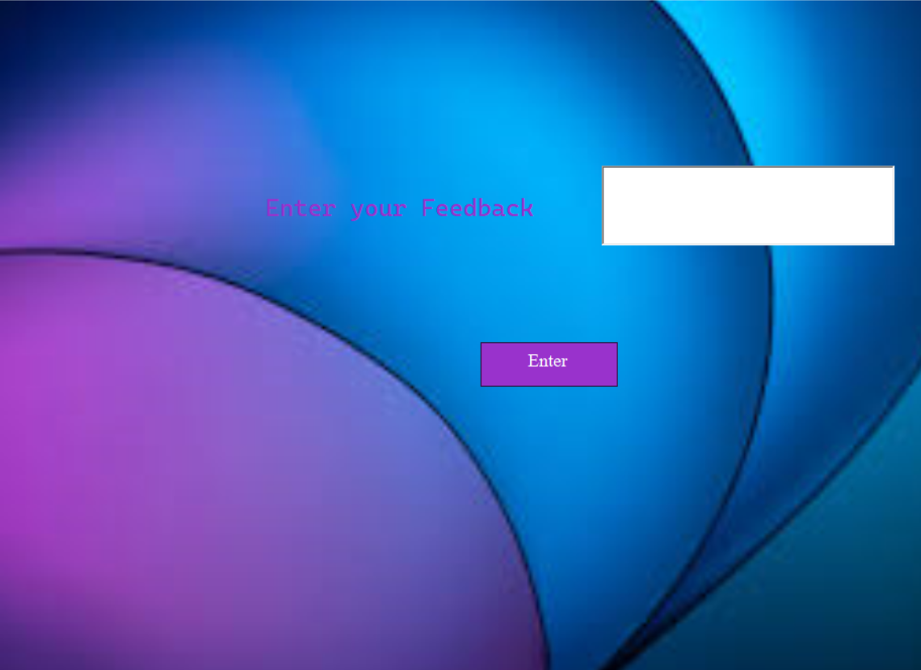

**Figure 13: Feedback**

**⦁COMPLETE CODE:**

**⦁Business Logic (BL) Classes:**

**User:**

public abstract class User

{

protected string Name;

protected string Password;

protected string Role;

public User(string name,string password, string role)

{

Name = name;

Password = password;

Role = role;

}

public string GetName() { return Name; }

public string GetPassword() { return Password; }

public string GetRole() { return Role.ToUpper(); }

public void SetName(string name) { Name = name; }

public void SetPassword(string password) { Password = password; }

public void SetRole(string role) { Role = role; }

public virtual string StoreInFile()

{

return $"{Name},{Password},{Role}";

}

public abstract void StoreInDB();

}

**Admin:**

public class Admin : User

{

public Admin(string name, string password, string role) : base(name, password, role)

{

}

public override void StoreInDB()

{

string ConnectionString = ConString.GetConnectionString();

using (SqlConnection conn = new SqlConnection(ConnectionString))

{

conn.Open();

SqlCommand cmd = new SqlCommand("INSERT INTO [Users] ([Username], [Userpassword], [Userrole], [Accountno], [Accountmoney],[Feedback]) values(@Username,@Password, @Role, null, null,null)", conn);

cmd.Parameters.AddWithValue("@Username", Name);

cmd.Parameters.AddWithValue("@Password", Password);

cmd.Parameters.AddWithValue("@Role", Role);

cmd.ExecuteNonQuery();

}

}

}

**Customer:**

public class Customer: User

{

private string AccountNo;

private double AccountMoney;

private List<Device> Devices;

private string Feedback;

public Customer(string name, string password, string role, string accountNo) : base(name,password,role)

{

AccountNo = accountNo;

AccountMoney = 0;

Devices = new List<Device>();

}

public string GetAccountNo() { return AccountNo; }

public double GetAccountMoney() { return AccountMoney; }

public void SetAccountNo(string accountNo) { AccountNo = accountNo; }

public bool SetAccountMoney(double accountMoney)

{

if (accountMoney > 400000) return false;

AccountMoney = accountMoney;

return true;

}

public string GetFeedback() { return Feedback; }

public void SetFeedback(string feedback) { Feedback = feedback; }

public void AddDevice(Device device) { Devices.Add(device); }

public List<Device> GetDevices() { return Devices; }

public void ClearDevices() { Devices.Clear(); }

public override string StoreInFile()

{

int i = 0;

string fileHandling = $"{Name},{Password},{Role},{AccountNo},{AccountMoney},{Feedback},";

foreach (Device device in Devices)

{

if (device != null)

{

fileHandling += device.GetModel();

if (i < Devices.Count - 1)

fileHandling += ";";

i++;

}

}

return fileHandling;

}

public override void StoreInDB()

{

string ConnectionString = ConString.GetConnectionString();

using (SqlConnection conn = new SqlConnection(ConnectionString))

{

conn.Open();

SqlCommand cmd = new SqlCommand("INSERT INTO [Users] ([Username], [Userpassword], [Userrole], [Accountno], [Accountmoney],[Feedback]) values(@Username,@Password, @Role, @AccountNo, 0,@Feedback)", conn);

cmd.Parameters.AddWithValue("@Username", Name);

cmd.Parameters.AddWithValue("@Password", Password);

cmd.Parameters.AddWithValue("@Role", Role);

cmd.Parameters.AddWithValue("@AccountNo", AccountNo);

cmd.Parameters.AddWithValue("@Feedback", " ");

cmd.ExecuteNonQuery();

}

}

}

**Device:**

public class Device

{

private string Type;

private string Company;

private string Model;

private double ModelPrice;

public Device(string type, string company, string model, double modelPrice)

{

Type = type;

Company = company;

Model = model;

ModelPrice = modelPrice;

}

public string GetDeviceType() { return Type; }

public string GetCompany() { return Company; }

public string GetModel() { return Model; }

public double GetModelPrice() { return ModelPrice; }

public void SetType(string type) { Type = type; }

public void SetCompany(string company) { Company = company; }

public void SetModel(string model) { Model = model; }

public void SetPrice(double price) { ModelPrice = price; }

}

* **Data Access Layer (DL) Classes:**

**⦁ User Interface (UI) Forms:**

* **CONCLUSION:**

In conclusion I will summarize my project idea and its achievements, challenges faced during developments and the new things I learnt from this project.

* **Challenges:**

However, the project also encountered some challenges along the way. One significant challenge was communication between different classes of the system. Managing a large data of admin and customers along with their account no and bought devices. while maintaining data maintainability and validation also posted its own set of challenges. Additionally, the most challenging moment for me is ORM during file-handling.

* **Lesson Learned:**

Throughout the project, several valuable lessons were learned. It became evident that effective planning and requirement gathering are crucial for the successful development of such a complex system. Modularity and separation of concerns played a vital role in achieving maintainability and flexibility. The implementation of design patterns, such as the BL, DL, and UI patterns, helped in achieving a structured and organized codebase. Furthermore, continuous testing and quality assurance were imperative to identify and resolve any issues early on.